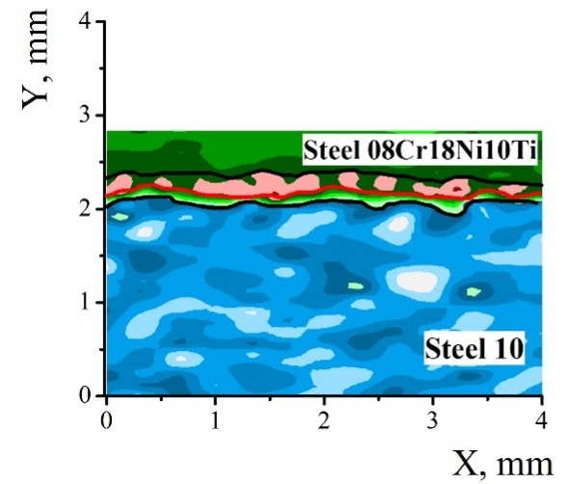
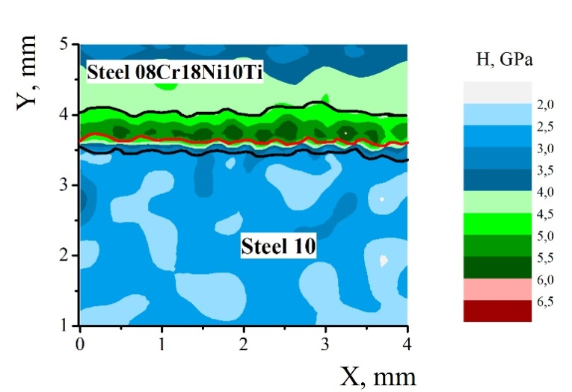

a b
Fig. S1. Microhardness distribution through the cross-section of the bimetal strip (the black lines indicate the weld boundaries, the red line is the weld boundary): after explosion welding (a); after the third pass of rolling (b).

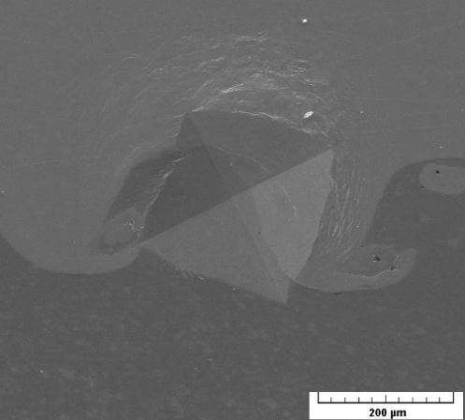

Fig. S2. Indentation in the weld zone of the “08Cr18Ni10Тi-steel 10” bimetal after explosion welding.

